Christ Episcopal Church of La Crosse, Wisconsin warmly welcomes all. We embrace friendship, hospitality, music, and the arts. You will always find fellowship, a friendly smile, a warm hug, inspiring music and great food.
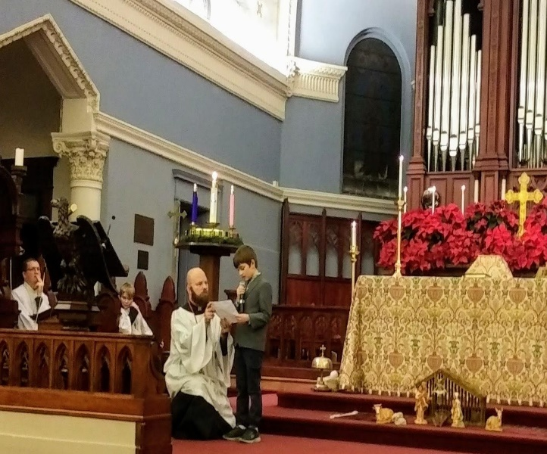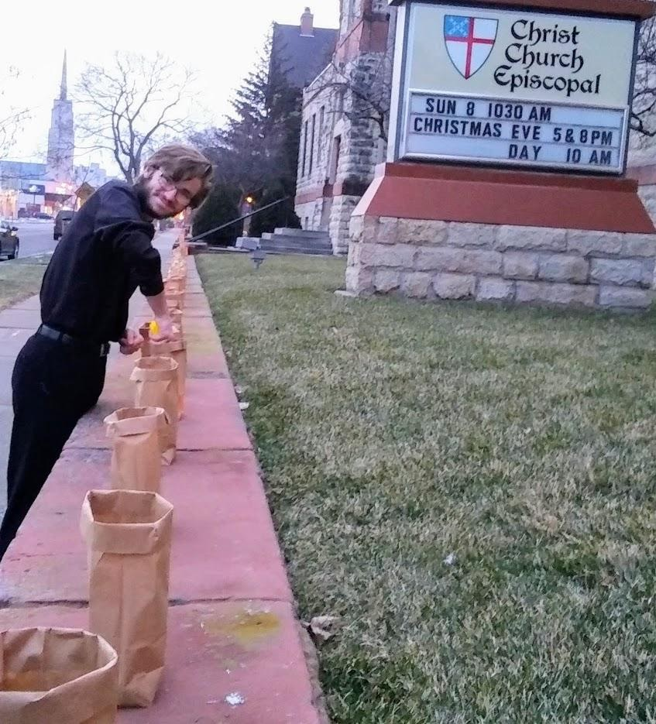
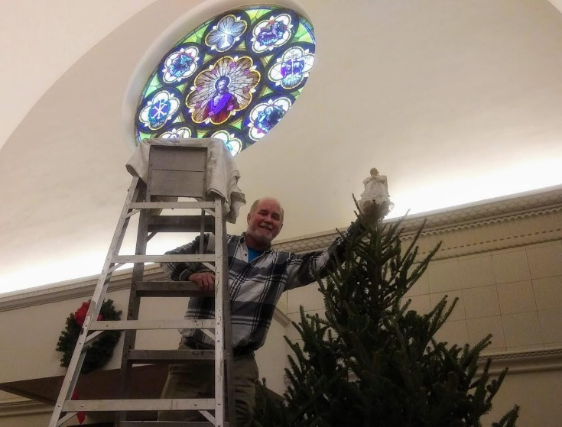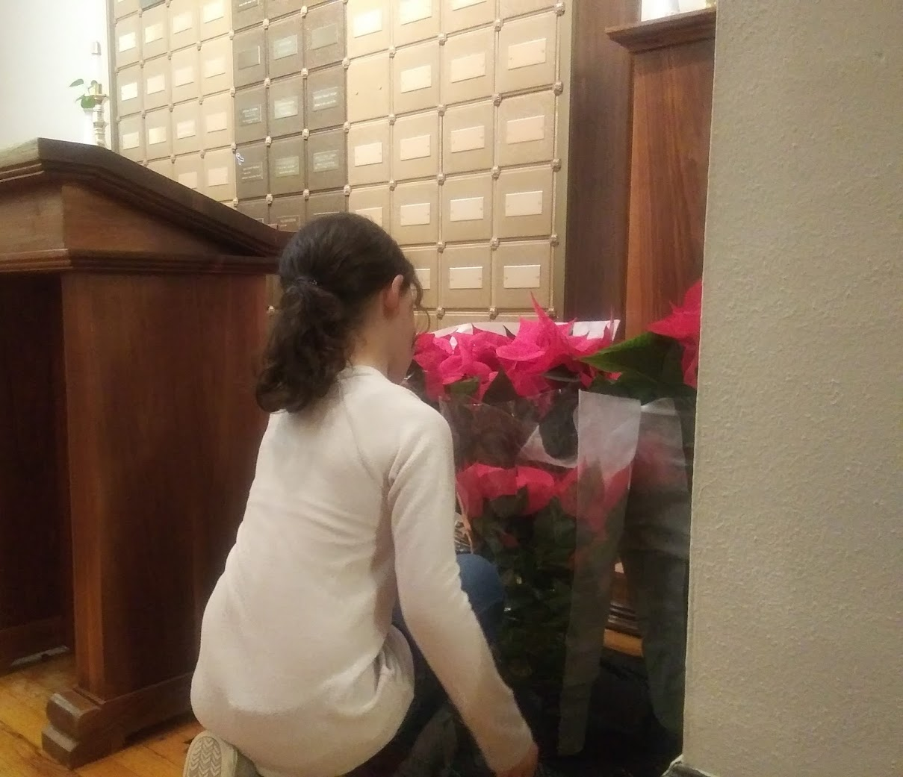

O God of patient and gentle strength, who knows our needs even before we ask, may your loving presence guide us as we seek the next Rector for our Parish. Give us an open spirit, discerning hearts and clear minds, that we may trust your will for us and become ever more united in your son our Savior, Jesus Christ. Inspire our conversation, deepen our prayer, and make us a community of humility and grace. Raise up for us, we pray, a priest and shepherd who will boldly proclaim your Gospel, faithfully administer your sacraments, and serve your people with love and compassion. All this we ask through Jesus our Lord, who lives and reigns with you and the Holy Spirit, now and forever. Amen.

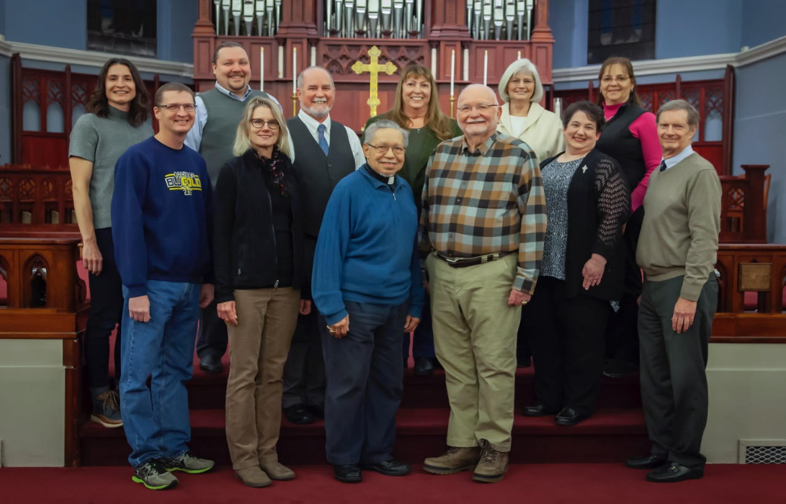
Interim Rector, Wardens and Vestry

History
Christ Church is the oldest continually operating congregation in La Crosse, WI. For nearly 170 years we have welcomed locals, travelers and guests. We are excited about the opportunities to grow our outreach, ministry and congregation, vibrantly sharing God’s grace and salvation for the next 100 years and beyond.

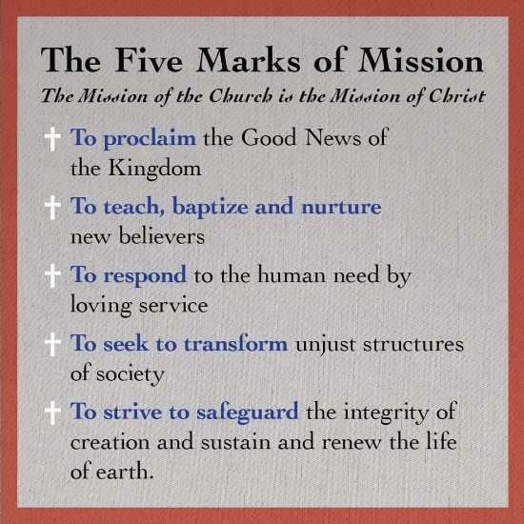

Missionary James Lloyd Breck celebrated the first Eucharistic service on Grandad bluff June 23, 1850, in prairie La Crosse. The missionaries camped by the Mississippi river overnight and climbed the bluff at dawn to perform the first Christian divine service in what became the City of La Crosse six years later.
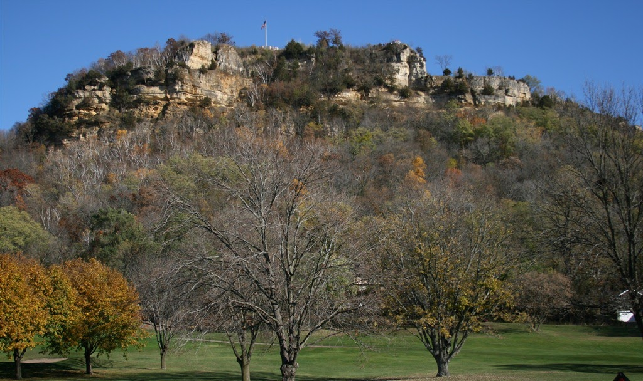

Grandad is a 600-foot bluff providing a spectacular view of the city, marsh and river. It hosts a park shelter where commemorative services are hosted. The surrounding Hixon Forest offers hiking, cross country skiing, running and snowshoeing trails.

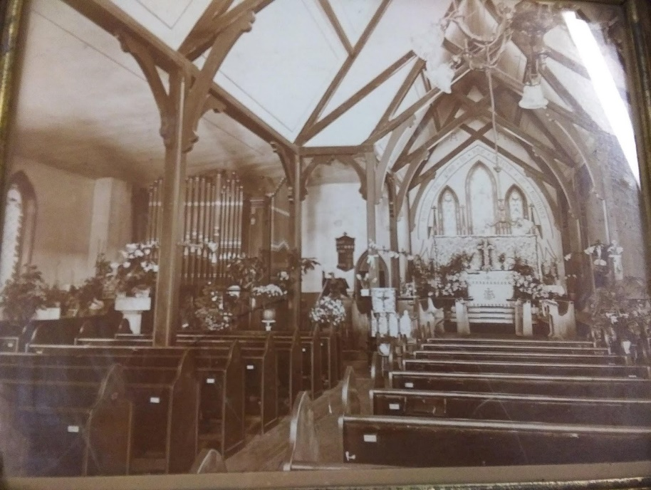
Church members met in homes until 1857 when the first church was built on the corner of 9th and Main Streets.
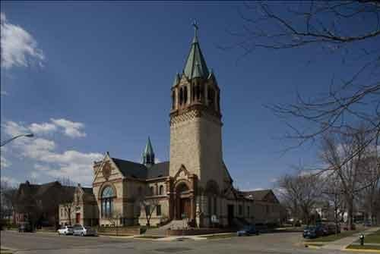
The size, beauty and acoustics of the sanctuary, adorned by heavenly stained-glass windows and glorious music, make it the perfect place to fall in love with the Lord. Urban Holmes's described Anglicanism at its best when "its poetry, its music and its life can create a world of wonder in which it is very easy to fall in love with God."
The ability to accommodate 300+ worshippers makes us the perfect location to host large Advent and Holy Week services, weddings, celebrations of life, and concerts. We are grateful recipients of stunning architecture that still retains its pertinence, glory and beauty nearly two centuries later.
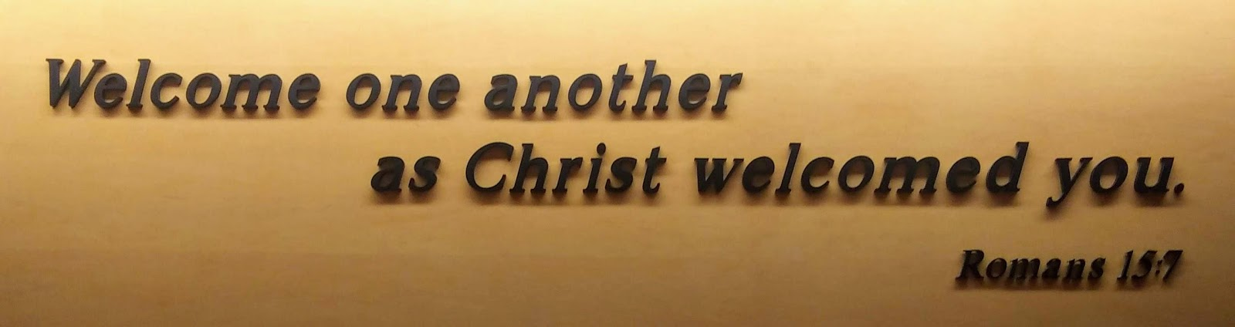
Who we Are –
We are a congregation whose mission is to know Christ and to make Him known to others. We are a welcoming congregation. You may be a cradle Episcopalian, a non-believer or somewhere in between. We are an inclusive community which supports all lifestyle choices. We want to be your loving family and home where you are nourished and grow in God’s love. We want to accompany you on a journey which deepens your faith, grounds you spiritually and surrounds you with loving acceptance. When we share the peace of our Lord - we mean it! Children eagerly scamper to share the peace with parents in the choir, while acolytes leave the altar to greet family in the pews. Our peace may take a while but we think it’s worth it!
We are in the heart of downtown and actively partner with the Salvation Army, New Horizons Shelter (from abuse), United Campus Ministries and Coulee Council on Recovery to make a difference in the lives of our neighbors and the greater La Crosse Community. We minister daily to those living on the margins of society seeking acceptance, spiritual guidance, financial assistance and hope in a world where they seek to find their place in God’s plan.
Hospitality, outreach, and education are all part of our mission within and beyond our congregation. We bring Communion, blessings, anointing, guidance and counseling to members within our parish as well as those who cannot come to church due to age, illness, or disability. We are committed to our children, seniors and all those in between.
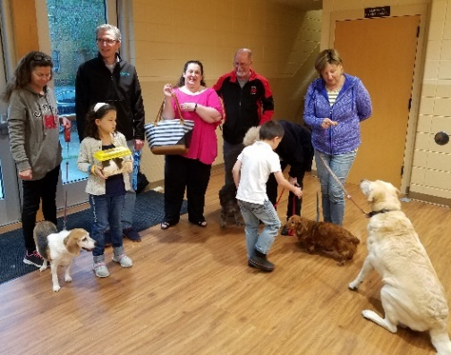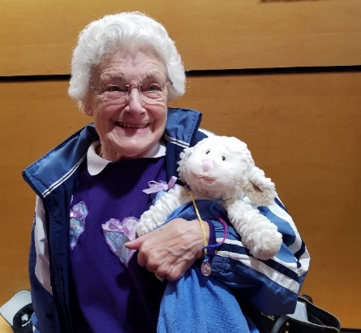
Annual blessing of the pets https://lacrossetribune.com/news/local/annual-blessing-of-the-pets-brings-creatures-great-and-small/article_88289d35-0a6f-5836-b7b0-029969bbeac6.html
Our church members include a broad cross section of society. La Crosse hosts two world class hospitals highly rated by the U.S. World News and Reports. We are home to three colleges; vast recreational, hunting and fishing opportunities; plus a thriving art and music scene. All within two miles of our front door. https://www.cityoflacrosse.org/visitors
We are one of 19 parishes of the Diocese of Eau Claire. We’re members of the worldwide Anglican Communion, part of the Episcopal Church in the United States of America who reside and worship in North and Western counties of Wisconsin.

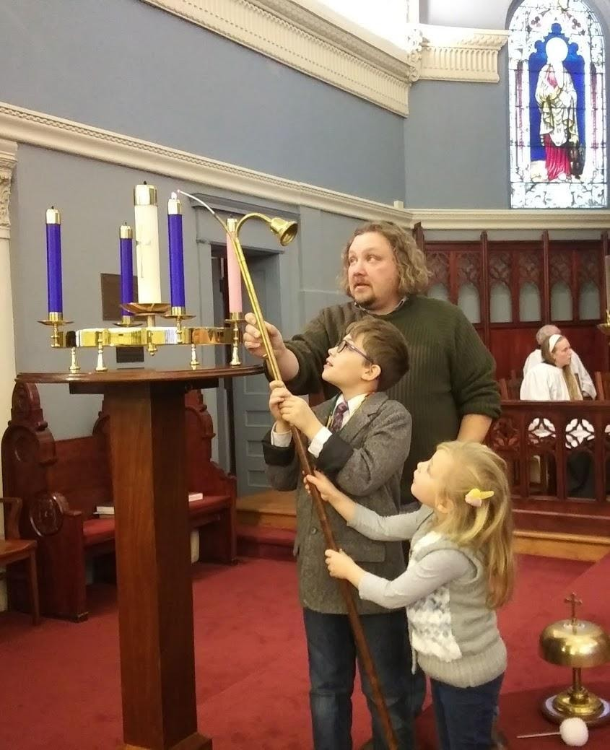
Educational and Spiritual Growth Ministries
Sunday School and Youth Group Programming – Youth and family ministry is our church’s top priority. We embrace children and families through active participation. We welcome children at the altar during monthly children’s sermons during the 10:30 service. We provide a coloring table in the rear of church for our youngest wigglers who just need to stretch during the service. The children lead the Christmas Eve procession with figurines from the Creche at the early Christmas Eve sing-a-long service. Most of our youth serve as acolytes and others learn about the Altar Guild while assisting their parents or grandparents.

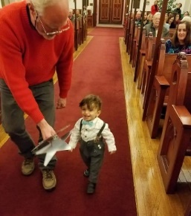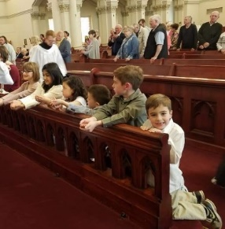

We engage children from 3 – 6 years old through the Godly Play program. “Middlers” 7-12 use Bible Fun Factory. Older teens use the Confirm not Conform program to prepare for Confirmation. Musicians teach children songs used in services and the kids sing as a group throughout the year.
First Holy Communion classes are held as needed. Confirmation is usually an annual event for teens and adults. The Youth Group hosts the Shrove Tuesday pancake supper and hosts a special Stations of the Cross service on Palm Sunday carrying a life size cross. This year our families created a special Stations of the Cross video which was uploaded to youtube.
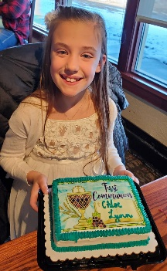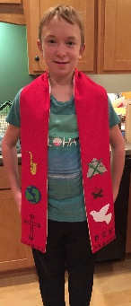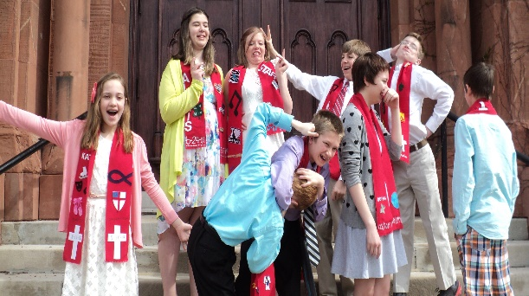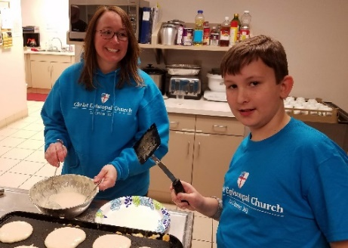
Our children participate in local service and global projects to provide food, clothing, and other essentials to partner organizations.
This year’s Confirmation class developed a Little Free Pantry project to be installed next to our primary entrance to address food insufficiencies in our area.
The Youth Group hosts picnics, a houseboat trip on the Mississippi River, and other outdoor activities which include all members of the parish.
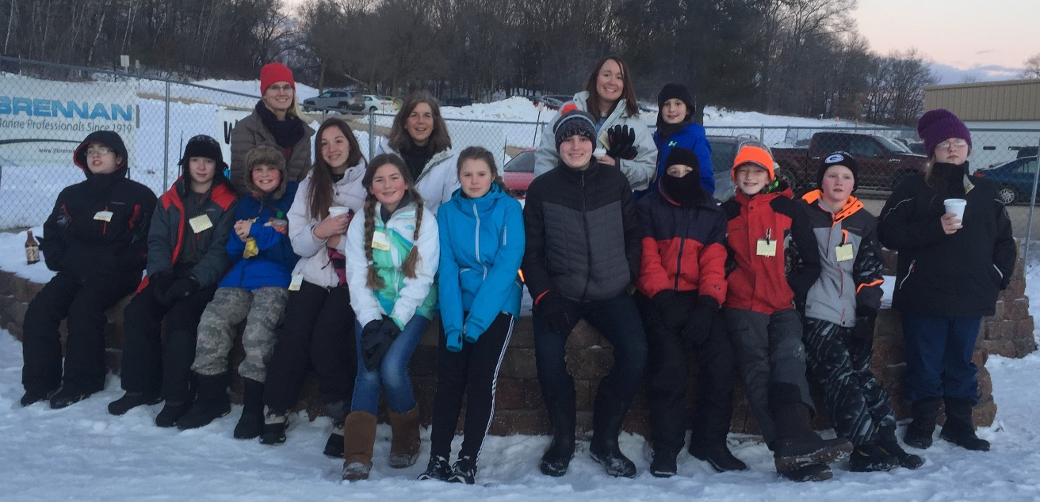
During Advent, teens and adults host baking days to provide Lay Eucharistic Visitors home baked treats sprinkled with love for those receiving home/hospital Communion.
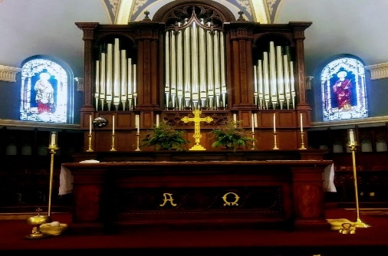
Music and Art
Music and art are valued and integral parts of our services. Our congregation includes many professional musicians and artists.
We have strong ties to orchestras, bands and chamber chorales. Our members comprise a rare quality of multi-faceted musicians (organist, pianist, harp, woodwinds, strings and flute among others) who generously share their talents during services.

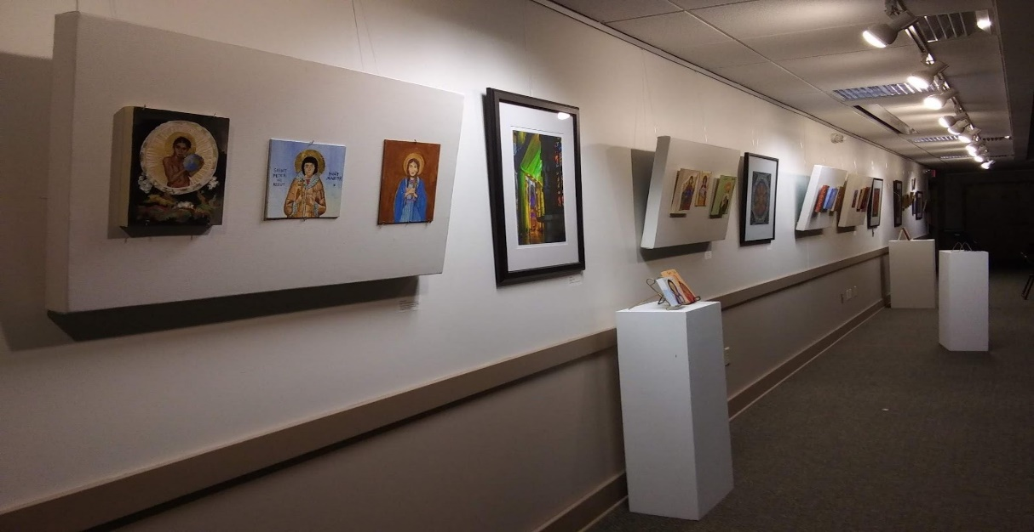
Our art gallery hosts monthly art receptions and our Icon guild meets and paints weekly.
Our sanctuary showcases artwork spanning fifteen decades of ministry. We believe in the power and holiness of religious art. Two windows are dedicated to the memory of founders Angus Cameron and Frank Hixon. The Hixon’s later bought land adjacent to Grandad bluff to preserve it as a public park and forest. The Cameron family dedicated a public park downtown which now serves as a farmer’s market featuring locally sourced foods. We are faithful stewards of La Crosse’s rivers, bluffs and trails, preserving them for future generations. We seek a rector who shares our love of Christ, his children, art, music and nature. Our goal is to thrive into the next century by being the reflection of Christ in our community.

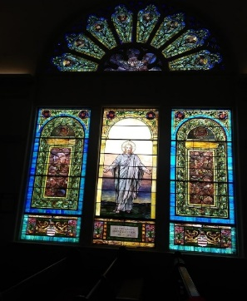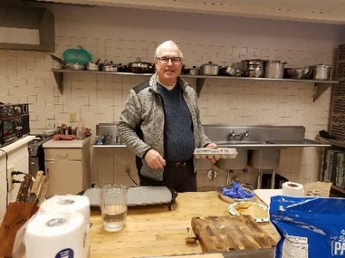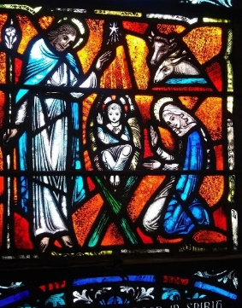
Accommodations
Vinter Hall was built in 1962 with office, gathering spaces, Sunday school rooms, nursery and later an elevator. In 2005, we completely renovated our Fellowship Hall to seat 300. Our commercial kitchen is used weekly for community meals and monthly potlucks. In 2013, we installed a T-coil hearing loop in the sanctuary for those with hearing aids. In 2017, we renovated the foyer and first floor adding more ADA Compliant restrooms and upgrades. We added a two vehicle drop off zone with curb less sidewalk and two heated ramps (to melt snow) leading to wide doors into the lobby with elevator. Our goal is to remove all barriers to attendance and full participation. We will bring you communion in the pew and provide gluten free wafers. We welcome many worshippers with unique needs including certified service animals.
Membership. In 2019, Christ Church had an Average Sunday Attendance of 112. One-third of that number attended the 8 AM Rite I service and the remainder the 10:30 AM Rite II service. We reported 202 members and 194 Communicants in Good Standing, 17 of our Communicants were under 16. Demographics suggest that our congregation has disproportionately more empty-nesters and retirees than the surrounding community.

Finances. Our Annual Operating Budget is $325,000. $250,000 is Plate & Pledge from our 130 financially active families. The remaining $75,000 comes from investment income from our $2.0 million Endowment Fund. The congregation is debt free. The vestry follows a practice of balancing its budget over the long run. That is, a modest deficit in one year is offset by a modest surplus in another. Shrinkage of our financial base over the last decade combined with maintenance needs of our 120-year old church building has created a challenging financial environment.

Baptism 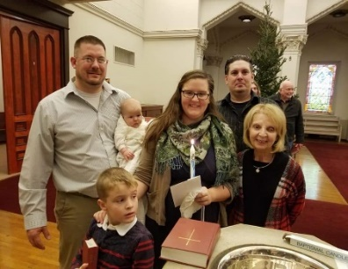 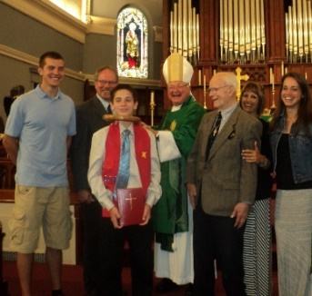 Bishop with the newly confirmed
Who We Seek as Rector
Growth -
Our new Rector will embrace challenges, and consider them opportunities for growth, renewal, expansion and inclusion. Our congregation is looking for a vibrant leader who will embrace opportunities to grow.
Spiritually Grounded, Good Gospel Preacher –
Our new Rector will be an insightful, inspiring preacher, bringing energy, compassion and joy to the worship of God --- a well-read leader who will be deeply grounded in scripture and committed to the sacraments and traditions of the Episcopal Church.
Expand Youth and Family Ministry –
Our new Rector will relate to families and young people. They will bless and empower our youth ministry and adult Christian education programs. We seek an educator who is experienced and committed to inspiring and incorporating children, youth, and families into the life of the congregation. Our new Rector will recognize that youth and family ministry is both the present and promising future of our church.
Humble, But a Leader –
Our new Rector will be a servant leader who creatively welcomes and guides the gifts and talents of lay leaders, empowering all to be servants in unity as the body of Christ.
Music Ministry –
Our new Rector will embrace our love of traditional music and invite diverse musical expression to enliven the choral and instrumental program. We are prayerfully searching for a new music director; we want our new Rector to be actively involved in the process finding a person with whom to coordinate Sunday messages and musical offerings. We, also, want our new Rector to be able to sing the high Mass.
Pastoral Care –
Our new Rector will actively walk with us on our faith journey, will stand with others in times of celebration and sorrow, and their comfort and counsel will remind us of God’s love and presence. The practice of home and hospital visits is strong in our church and our new Rector will be eager to continue this important mission.

